**Calculating Family Expenses using Service Now**

**Team Id:** NM2025TMID14578

**Team Members:** 4

**Team Leader:** MOORTHY V

**Team Member :** BARATH S

**Team Member :** JOEL S

**Team Member :** BALAJI B

**Problem Statement:** The project aims to develop a comprehensive expense calculation system using ServiceNow. This system will enable users to track and manage family expenses efficiently. It will include features such as expense categorization, budget setting, real-time tracking, and reporting capabilities. Utilizing ServiceNow's robust platform, the project will ensure seamless integration, user-friendly interface, and scalability to accommodate varying family sizes and financial complexities. The end goal is to empower users with the tools they need to make informed financial decisions and promote financial well-being within the family unit.

**Objective:**

The objective of this project is to develop a user-friendly expense management system on the ServiceNow platform. It enables families to categorize expenses, set budgets, and track spending in real-time. The goal is to support informed financial decisions and promote financial stability within the household.

**Skills:**

The project uses ServiceNow application development, including form design, workflow automation, and scripting with JavaScript. It also involves creating reports, dashboards, and secure user access. Additional skills include problem-solving, UI/UX design, and data analysis for financial insights.

**TASK INITIATION**

**Milestone 1 : Creation of New Update Set**

**Activity 1:** **Create Local Update set**

1. Open service now
2. Click on All >> search Local Update set
3. Select Local Update set under system update set
4. Click on new
5. Fill the following details to create,name as family expenses
6. Click on submit and make current

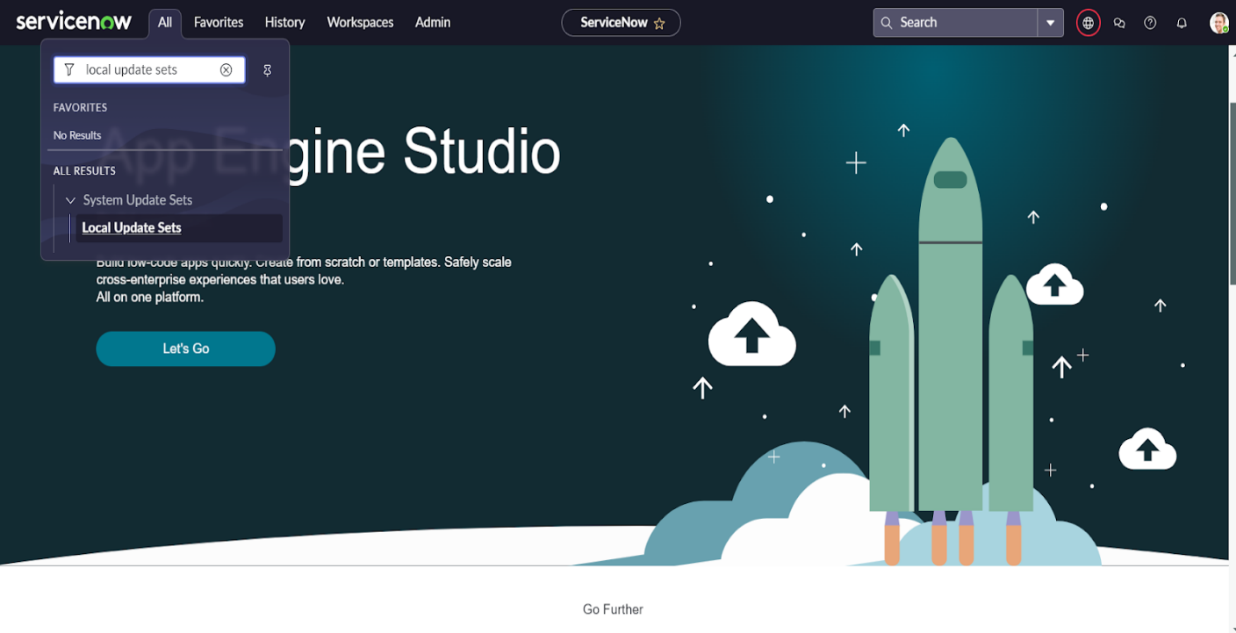

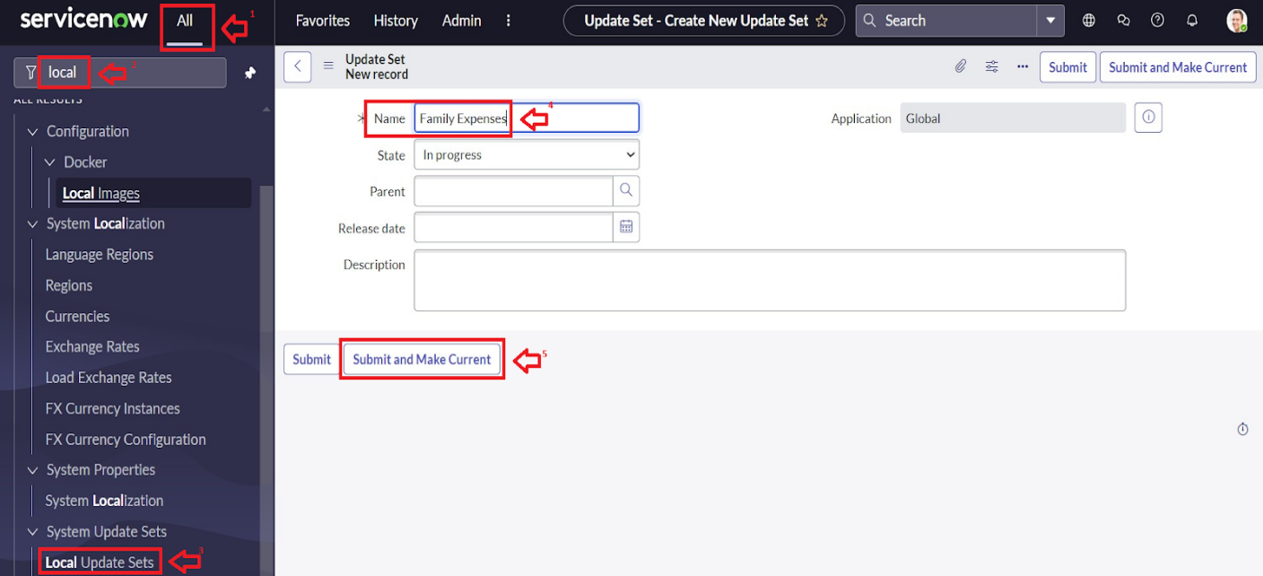

**Milestone 2 : Creation Of Table(Family Expenses)**

**Activity 1:** **Creation Of Family Expenses Table**

1. Open service now.
2. Click on All >> search for tables
3. Select tables under system definition
4. Click on new
5. Fill the following details to create a new table

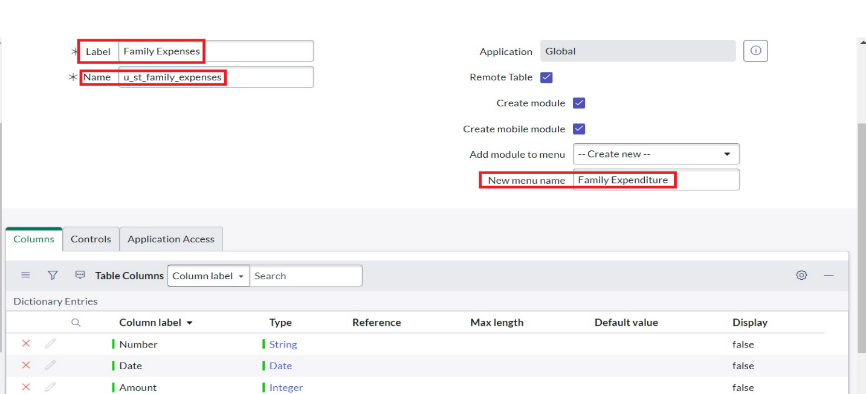

1. Click on save

**Activity 2:** **Creation Of Columns(Fields)**

1. Near Columns Double click near insert a new row.
2. Give the details as:

Column label : Number

Type : String

1. Double click on insert a new row again
2. Give the details as:

Column label : Date

Type : Date

1. Double click on insert a new row again
2. Give the details as:

Column label : Amount

Type : Integer

1. Double click on insert a new row again
2. Give the details as:

Column label : Expense Details

Type : String

Max length : 800

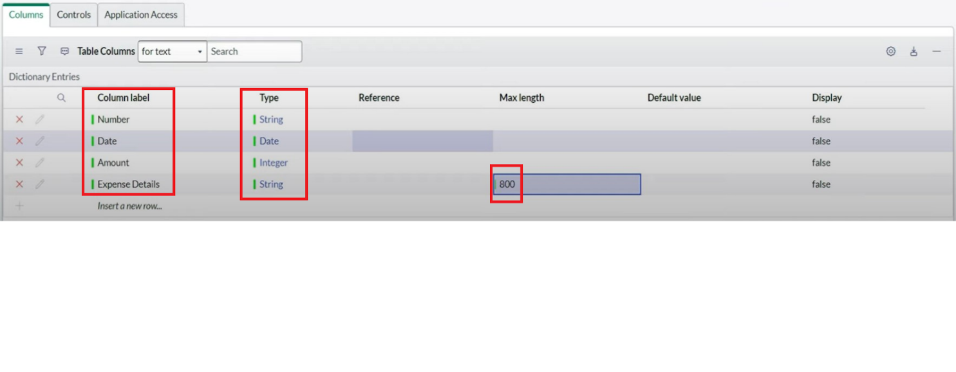

9. Click on save

**Activity 3:** **Making Number Field an Auto-Number**

1. Double click on the Number Field/Column.
2. Go down and double click on Advanced view
3. In Default Value:

Use dynamic default : check the box

Dynamic default value : Get Next Padded Number

1. Click on Update

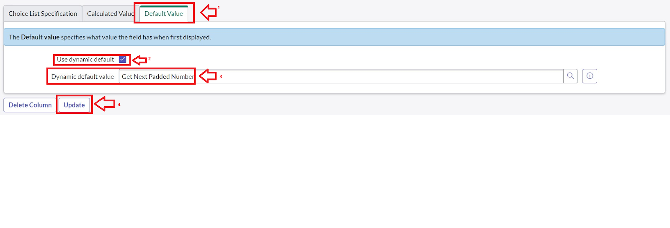

1. Go to All >> In the filter search for Number Maintenance >> select Number Maintenance
2. Click on New
3. Enter the below Details:

Table : Family Expenses

Prefix : MFE

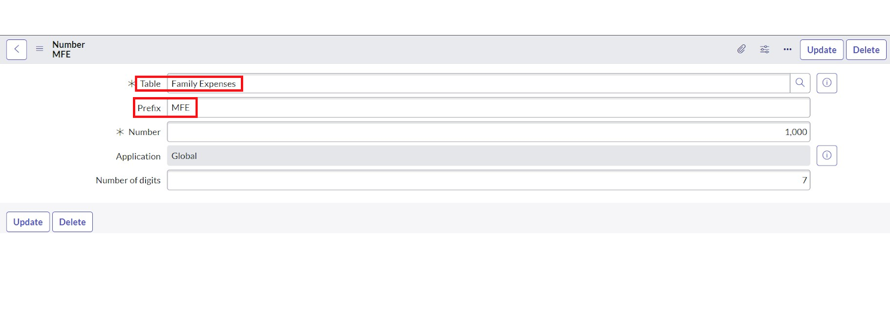

1. Click on submit

**Activity 4:** **Configure the Form**

1. Go to All >> In the filter search for Family Expenses >> Open Family Expenses
2. Click on New
3. Go to the Header and right click there>> click on Configure >> Select Form Design
4. Customize or Drag Drop the form as per your requirement.

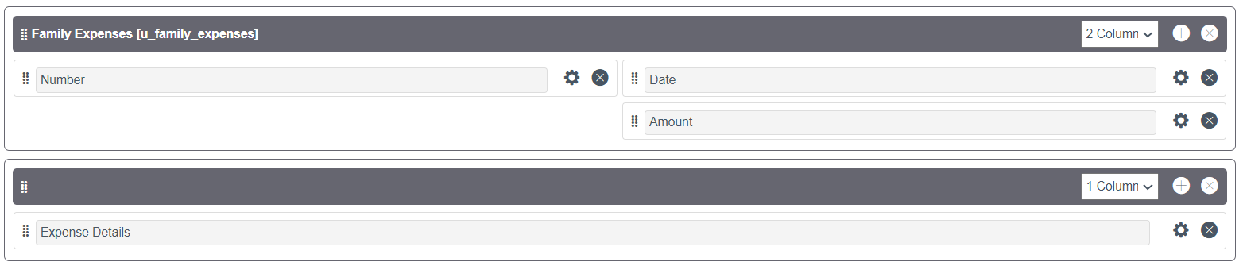

1. Make Number Read-Only Field by clicking on the gear icon and checking Read-Only
2. Make Date, Amount Mandatory Field by clicking on the gear icon and checking Mandatory
3. Click on Save.

**Milestone 3 :**  **Creation of Table(Daily Expenses)**

**Activity 1:** **Creation of Daily Expenses Table**

1. Open service now
2. Click on All >> search tables
3. Select tables under system definition
4. Click on new
5. Fill the following details to create a daily expenses

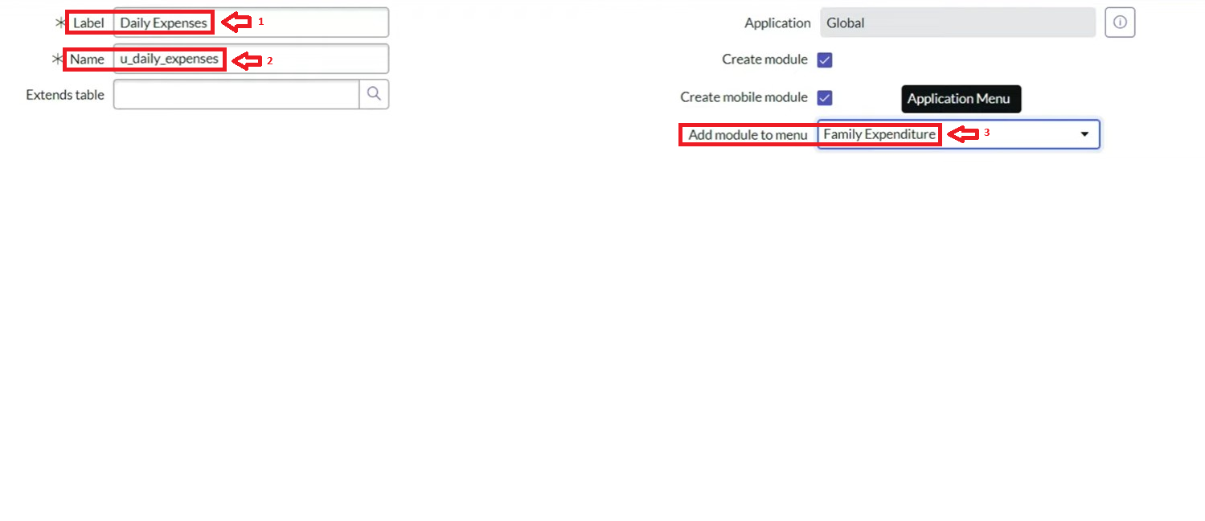

1. Click on save

**Activity 2:** **Creation of Columns(Fields)**

1. Near Columns Double click near insert a new row.
2. Give the details as:

Column label : Number

Type : String

1. Double click on insert a new row again
2. Give the details as:

Column label : Date

Type : Date

1. Double click on insert a new row again
2. Give the details as:

Column label : Expense

Type : Integer

1. Double click on insert a new row again
2. Give the details as:

Column label : Family Member Name

Type : Reference

Max length : 800

1. Double click on insert a new row again
2. Give the details as:

Column label : Comments

Type : String

Max length : 800

1. Go to the Header and right click there>> click on Save**.**

**Activity 3:** **Making Number Field an Auto-Number**

1. Double click on the Number Field/Column.
2. Go down and double click on Advanced view
3. In Default Value:

Use dynamic default : check the box

Dynamic default value : Get Next Padded Number

1. Click on Update



1. Go to All >> In the filter search for Number Maintenance >> select Number Maintenance
2. Click on New.
3. Enter the below Details:

Table : Daily Expenses

Prefix : DFE

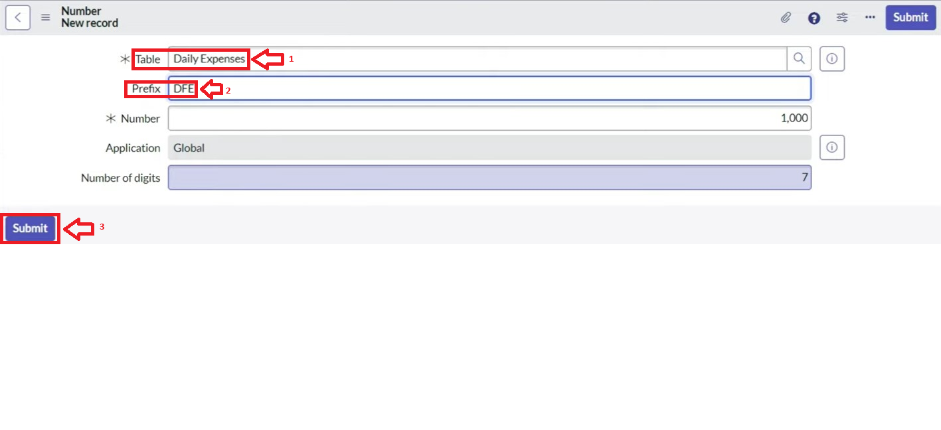

1. Click on submit

**Activity 4:** **Configure the Form**

1. Go to All >> In the filter search for Daily Expenses >> Open Daily Expenses
2. Click on New
3. Go to the Header and right click there>> click on Configure >> Select Form Design
4. Customize or Drag Drop the form as per your requirement

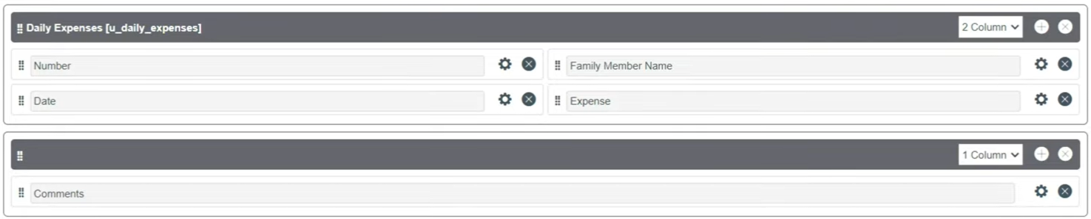

1. Make Number Read-Only Field by clicking on the gear icon and checking Read-Only
2. Make Date, Family Member Name Mandatory Field by clicking on the gear icon and checking Mandatory
3. Click on Save

**Milestone 4 : Creation of Relationship**

**Activity 1:** **Creation of Relationship Between Family Expenses And Daily Expenses**

1. Open service now.
2. Click on All >> search for relationship
3. Select relationship under system definition
4. Click on new
5. Enter the details:

Name : Daily Expenses

Applies to table : Select Family Expenses

Daily Expenses : Select Daily Expenses

6. Click on save

**Milestone 5 : Configuring Related List on Family Expenses**

**Activity 1:** **Configuring Related List on Family Expenses**

1.Open service now.

2.Click on All >> search for family expenses

3.Select family expenses under family expenditure

4.Go to the Header and right click there>> click on Configure >> Select Related Lists

5.Add Daily Expenses to the Selected Area.

6.Click on Save

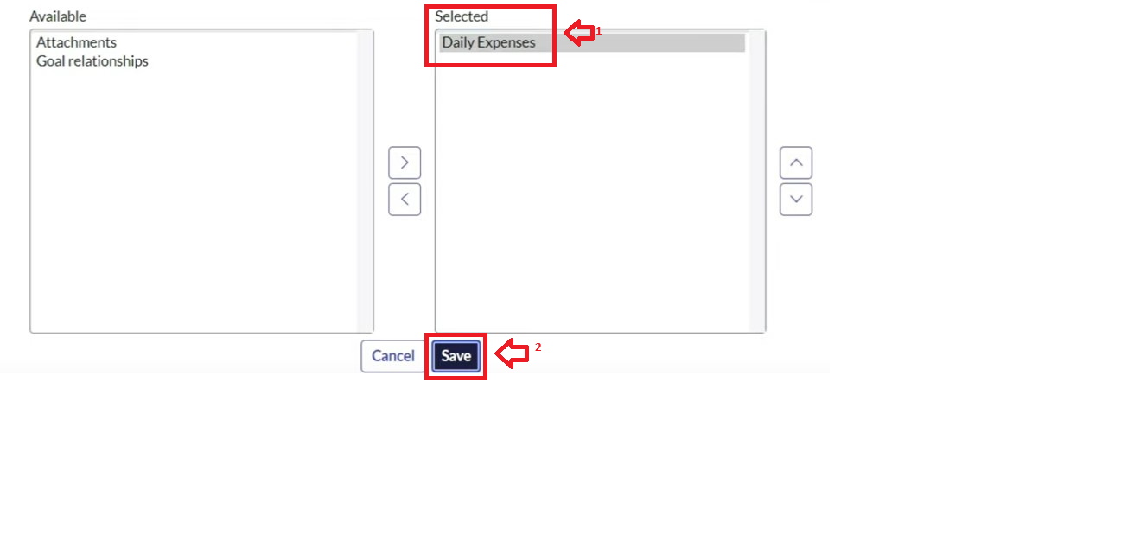

**Milestone 6 : Creation of Business Rules**

**Activity 1:** **Creation of Business Rules**

1. Open service now.
2. Click on All >> search for business rules
3. Select business rules under system definition
4. Click on new
5. Enter the details:

Name : Family Expenses BR

Applies to table : Select Daily Expenses

Check Advanced

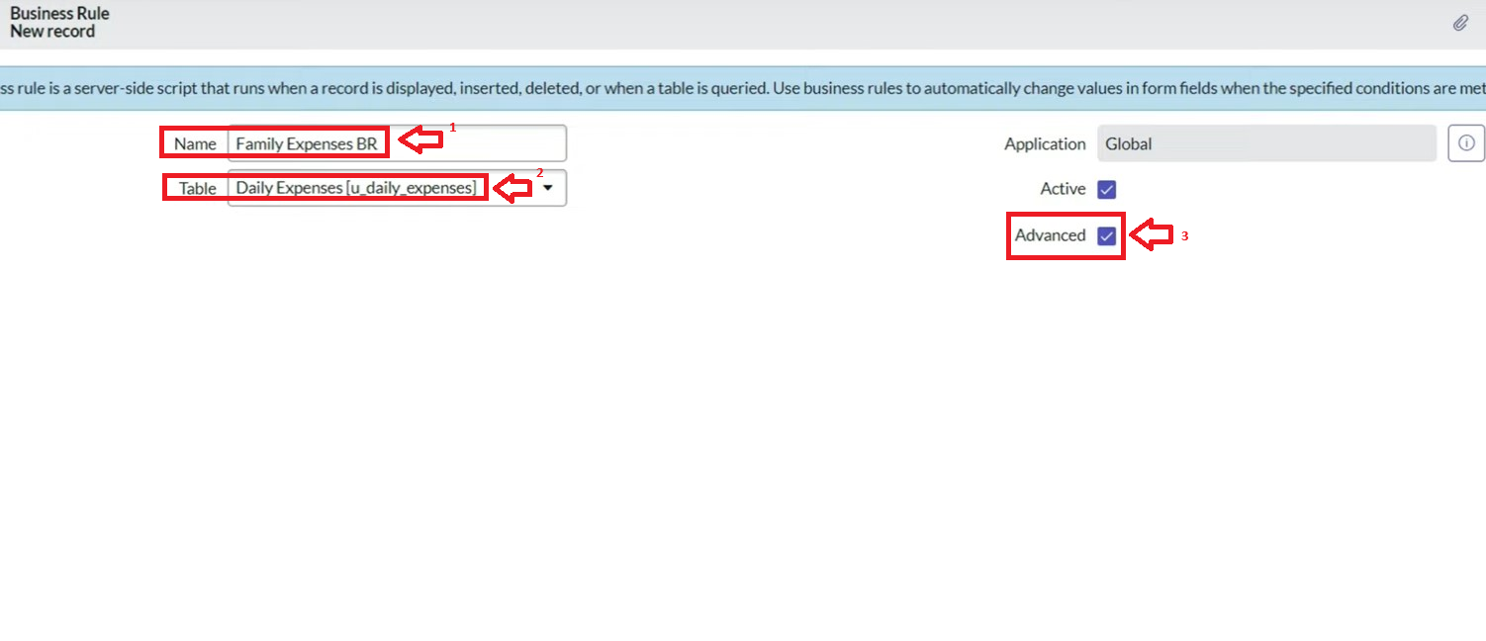

6.In when to run Check Insert and Update

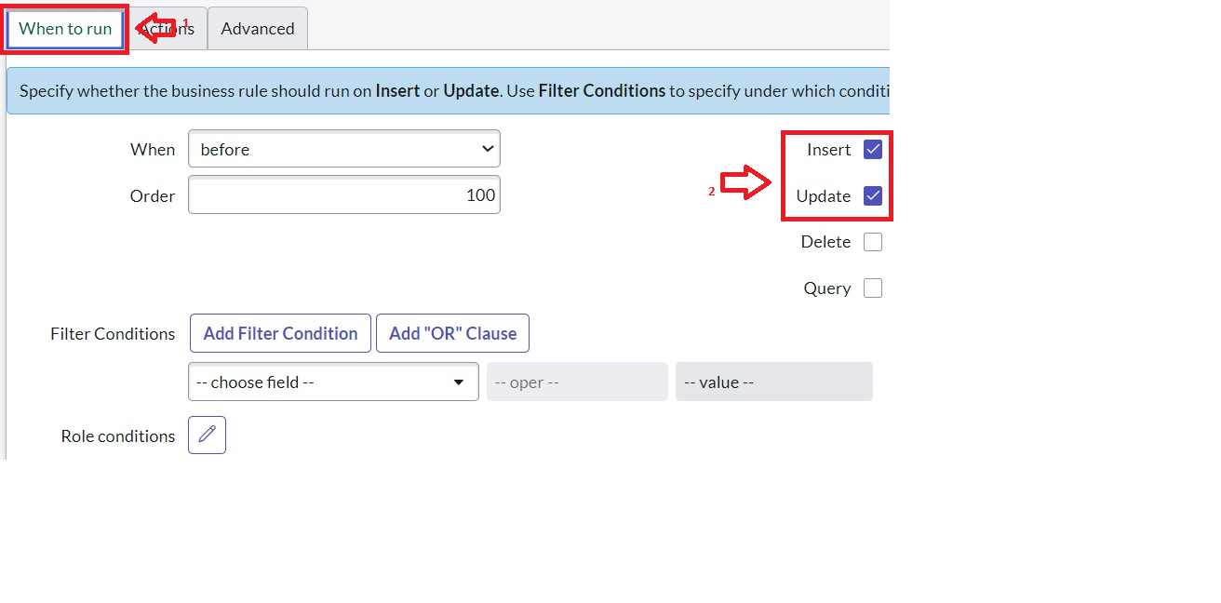

7. In Advance(we write the code): Write the below code >>

(function executeRule(current, previous /*null when async*/) {

var FamilyExpenses = new GlideRecord('u_family_expenses');

FamilyExpenses.addQuery('u_date',current.u_date);

FamilyExpenses.query();

if(FamilyExpenses.next())

{

FamilyExpenses.u_amount += current.u_expense;

FamilyExpenses.u_expense_details += ">"+current.u_comments+":"+"Rs."+current.u_expense+"/-";

FamilyExpenses.update();

}

else

{

var NewFamilyExpenses = new GlideRecord('u_family_expenses');

NewFamilyExpenses.u_date = current.u_date;

NewFamilyExpenses.u_amount = current.u_expense;

NewFamilyExpenses.u_expense_details += ">"+current.u_comments+":"+"Rs."+current.u_expense+"/-";

NewFamilyExpenses.insert();

}

})(current, previous)

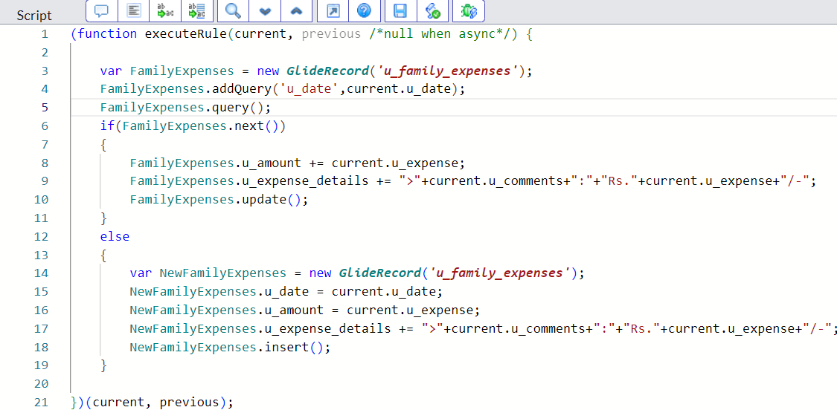

8. Click on save

**Milestone 7 : Configure the Relationship**

**Activity 1: Configure the Relationship**

1.Open service now.

2.Click on All >> search for relationships

3.In that,open Daily Expenses Relationship

4.For applies to table : select Family Expenses

5. In Query with : write the below Query.

(function refineQuery(current, parent) {

// Add your code here, such as current.addQuery(field, value);

current.addQuery('u_date',parent.u_date);

current.query();

})(current, parent);

6.Click on update

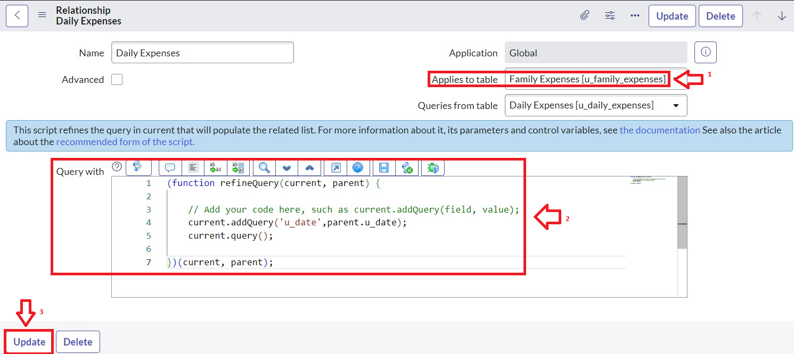

**Conclusion :**  the development of a family expense calculation system using ServiceNow offers a practical and scalable solution for managing household finances. By leveraging ServiceNow’s powerful platform, the system provides essential features such as expense categorization, budget planning, real-time tracking, and insightful reporting. This project not only simplifies financial management but also empowers families to make informed financial decisions, enhance transparency, and promote long-term financial well-being. As a result, it contributes to building healthier financial habits and fostering greater financial stability within the family unit.